MClimate Fan Coil Thermostat (FCT)

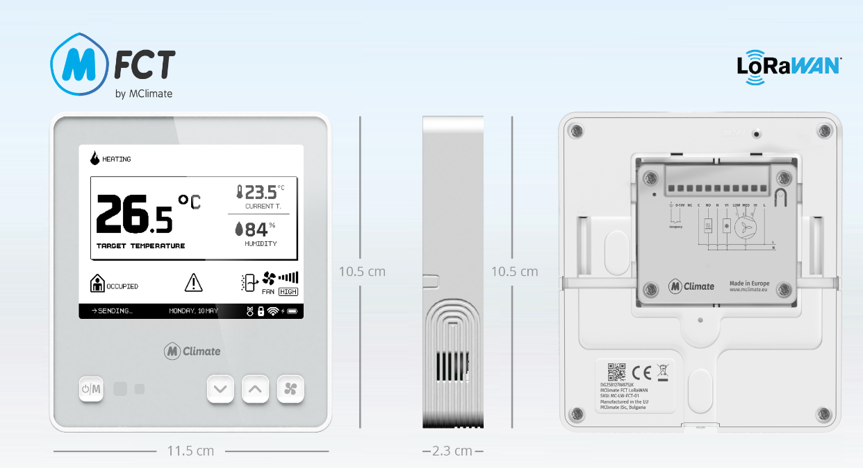

General information
MClimate Fan Coil Thermostat (FCT) is a thermostat compatible with 2-pipe and 4-pipe Fan Coil Units with 4 SPST relays, 1 DPST dry relay and 0-10V input/output. It features a 4.2" e-ink display, digital temperature and humidity sensor, and 4 buttons. It communicates over LoRaWAN and allows for rapid retrofit of buildings, offering modern BMS capabilities.

Features
- Temperature and humidity sensor
- Compatible with 2-pipe and 4-pipe Fan Coil Units (FCU).
- Manual adjustment of target temperature
- 4.2" e-ink display
- Optional changeover temperature sensor
- 0-10V input/output
- Child lock (ability to lock manual temperature adjustment)

Power supply
- 100-240VAC 50Hz

Compatibility
- LoRaWAN 1.0.3, Class C device, EU868
- Encryption: LoRaWAN End-to-end encryption (AES-CTR)
- Activation: OTAA
- Link budget: 130dB
- RF Transmit Power: 14dB

